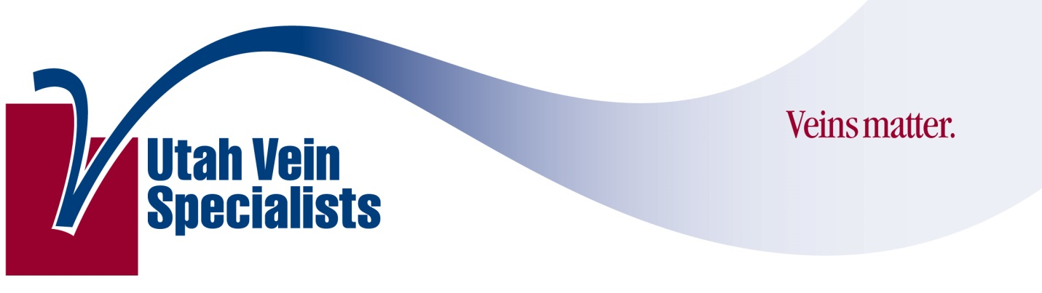
Venous Screening Program

Patient Name: ________________________________________ DOB:_______________

By signing this agreement I give consent to the physicians, medical staff and employees of Utah Vein Specialists to provide a screening for venous disease. I further understand that this screening does not constitute a complete medical exam or diagnosis. I hereby release the screening provider from all responsibility in connection with the screening exam.

Signature _____________________________________________, ________________(Date).

